Web Programming Project

Phase 2

CSC 350: Web Programming

Professor Cordio

Group Members:

Angel Bajracharya

Sabawoon Popal

Due:

12/10/23

# Table of Contents

**Project Purpose** **4**

**List of Functions/Features** **4**

**Technologies/Tools Used** **5**

**Appendices** **6**

Appendix A: Screenshots of Website 6

Appendix B: Demo Video 9

Appendix C: Source Code Repository 9

# 

# 

# 

# 

# 

# 

# 

# 

# 

# Project Purpose

Our project was designed to serve as a financial planning platform for users. Financial literacy is a very important skill that is often overlooked. We hope that our website can aid in visualizing financial saving goals. Our main services are the budget calculator and the cash flow calculator.

Our budget calculator takes in user information such as saving goal amount, time range, starting value amount, minimum monthly saving, and net monthly income to generate a report that helps users visualize the ideal timeframe that they can save money in depending on various factors. We take into consideration three scenarios: Scenario A, where you meet your saving goal in the time frame that you chose and entered as an input; Scenario B, where you meet your saving goal with the minimum amount you’re able to save; and Scenario C, where you meet your saving goal using the 50-30-20 rule. The 50-30-rule is an economic rule that states you should set aside 50% of your income for needs, 30% for wants, and 20% for savings. The ultimate goal of the budget calculator is to aid in the visualization of the varying timeframes that each of these scenarios would

Our goal with this website is to create a holistic financial planning aid that will allow users to make optimal financial decisions and to help them visualize their cash flow in an easy-to-use application.

# List of Functions/Features

* Nav Bar - hyperlinks for easy navigation to each HTML page
  + Home
  + About Us
  + Services
    - Budget Calculator
    - Cash Flow Calculator
  + Help
* Budget Calculator
  + Generate budget report
  + Print budget report
* Cash Flow Calculator
  + Generate cash flow report
  + Print cash flow report
* Tip Cycle
  + A carousel of common financial tips
* Help
  + Submit a question/complaint

# Technologies/Tools Used

* Github
* Folder Stored Locally
* VSCode

The use of certain technologies was critical in assisting with the development of our financial planner web project. It quickly became clear that we needed a software/tool that would allow us to share the files and code together and make live changes to them. Our website was created using a combination of HTML, CSS, and JS. We used Github and VSCode as our source control system.

Reflection

In the aftermath of this project, our team learned how to identify a need in the market and develop a web-based solution from concept to implementation. Although the both of us were familiar with HTML and CSS before this project, we were able to practice implementing Javascript in order to dynamically render certain attributes in the website. It was helpful for us to be able to complete the project from start to finish with our own schedules. It felt closer to the real world experience.

# Appendices

## Appendix A: Screenshots of Website

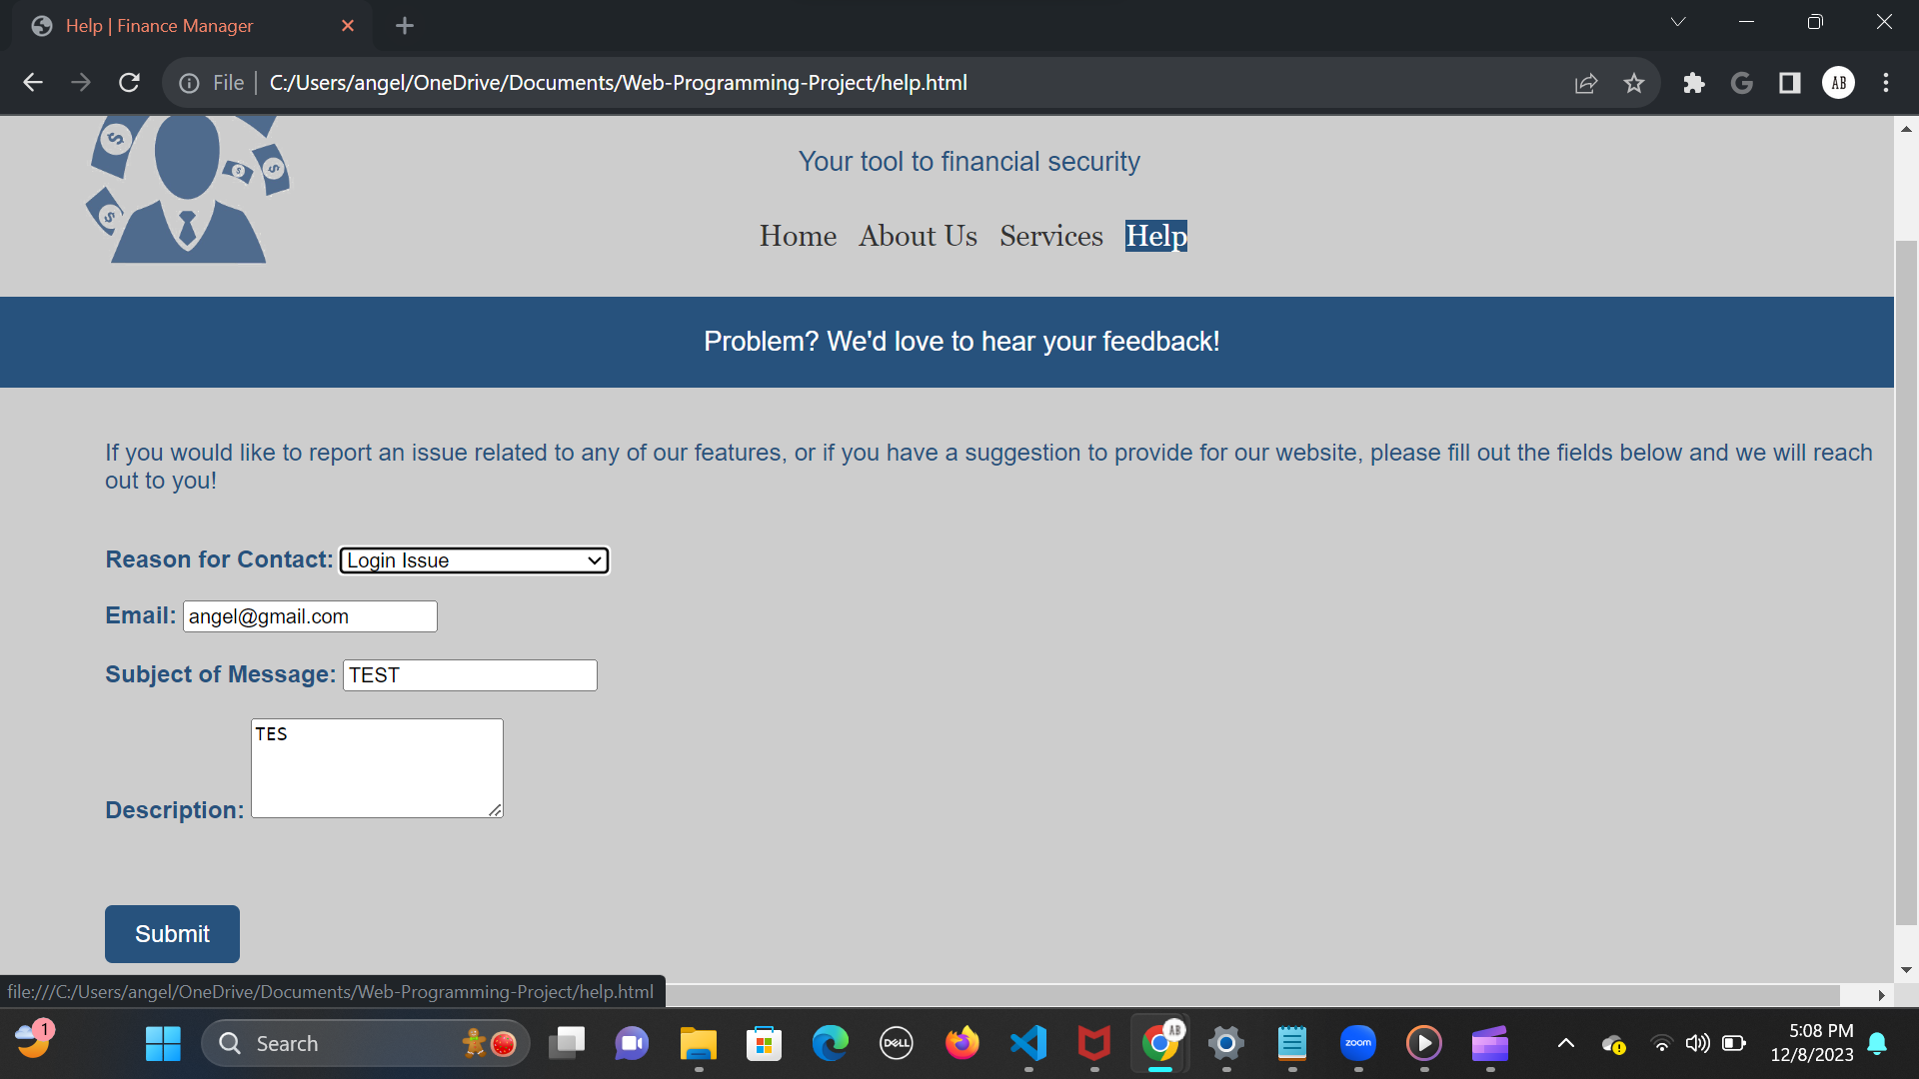

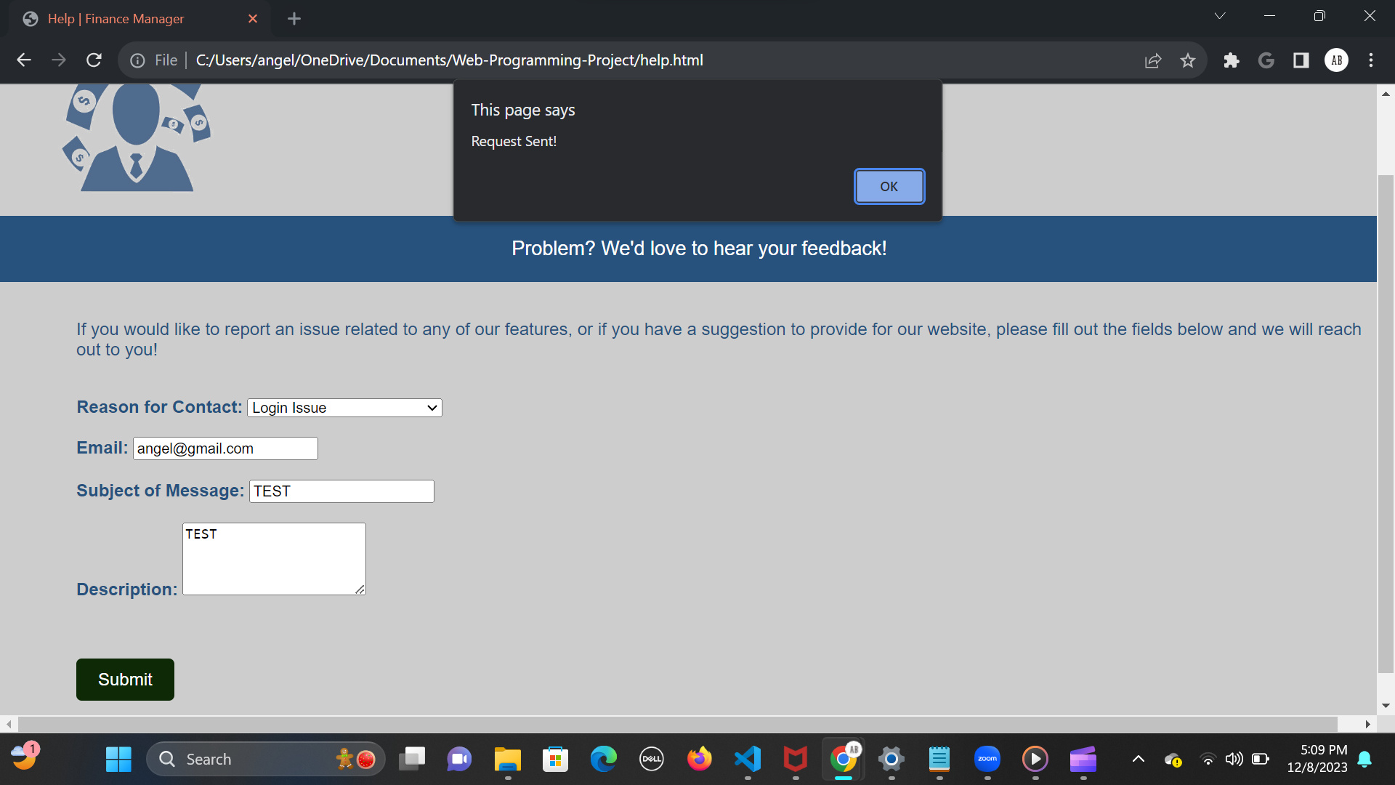

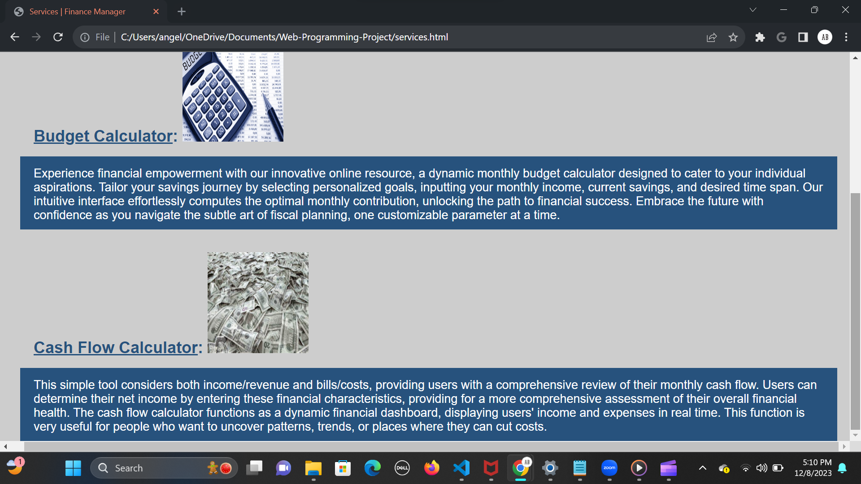

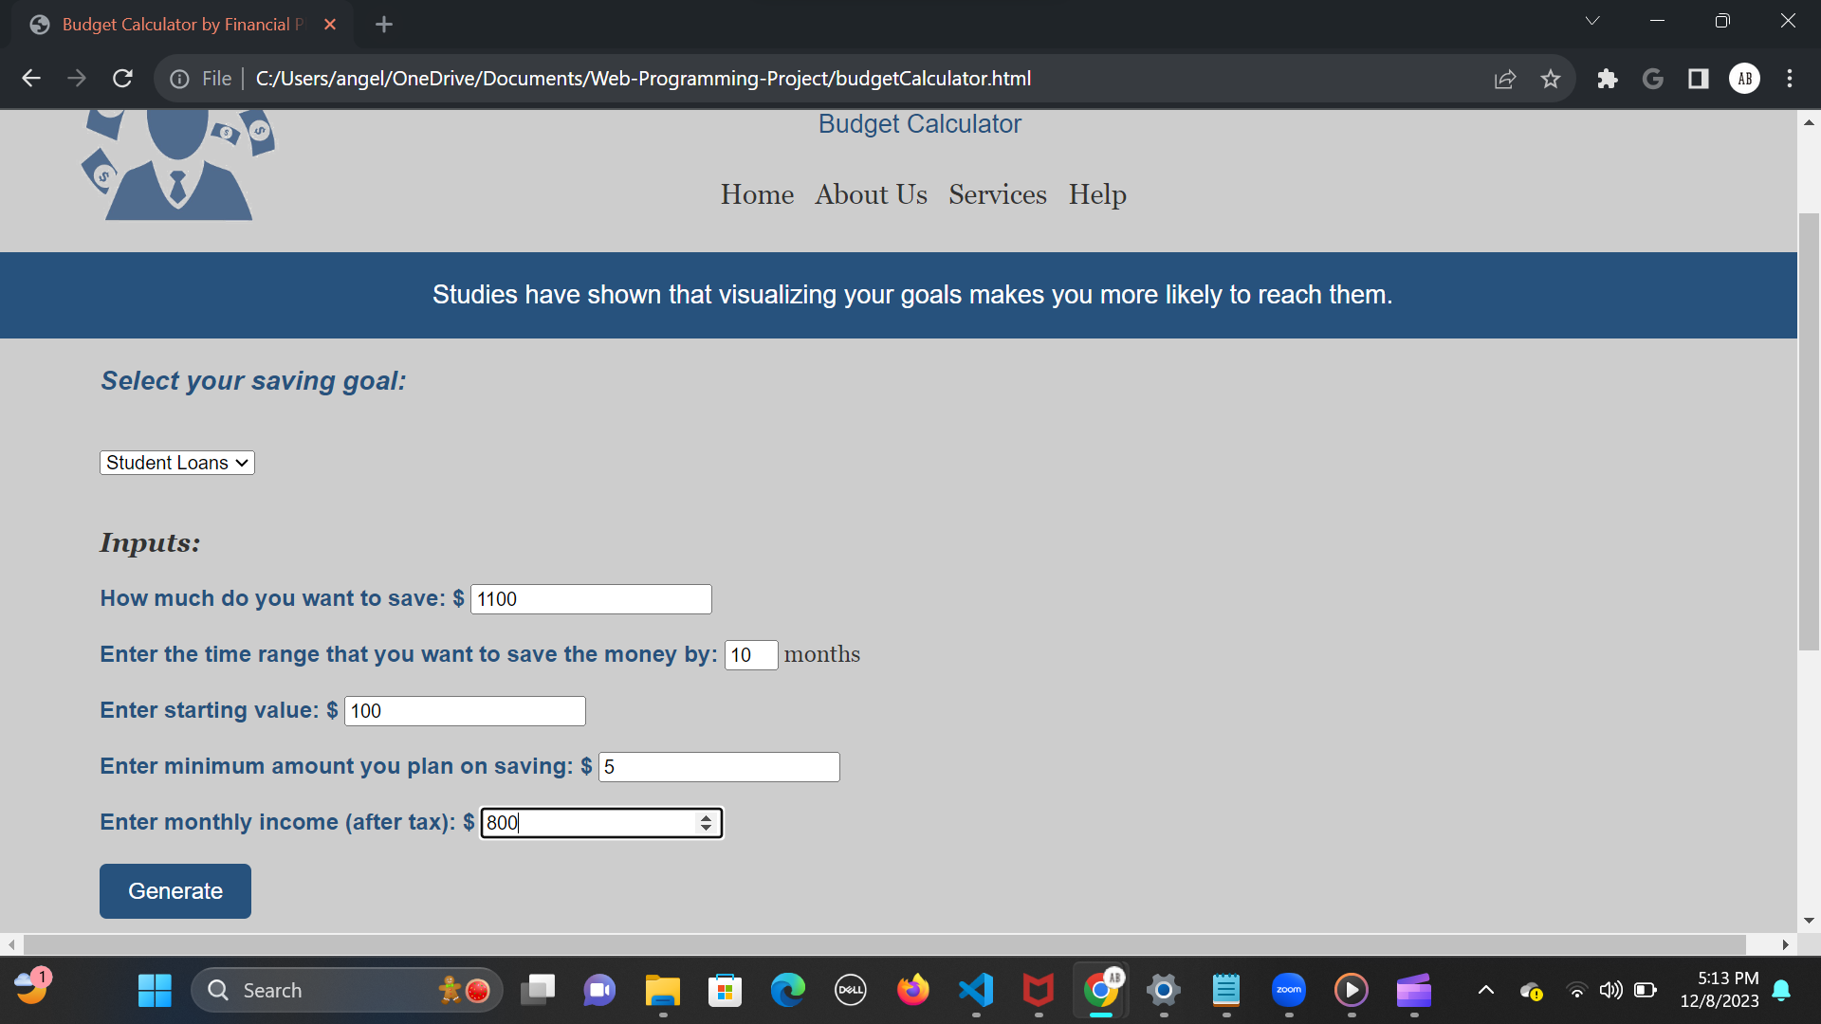

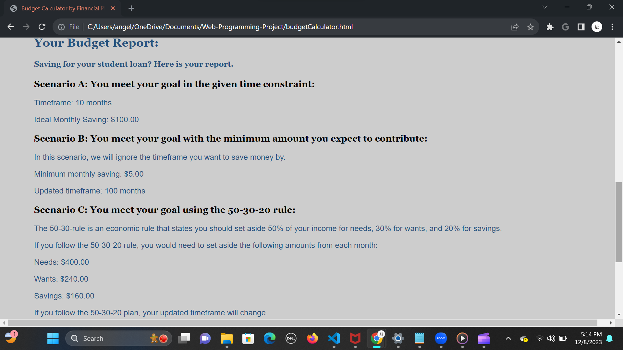

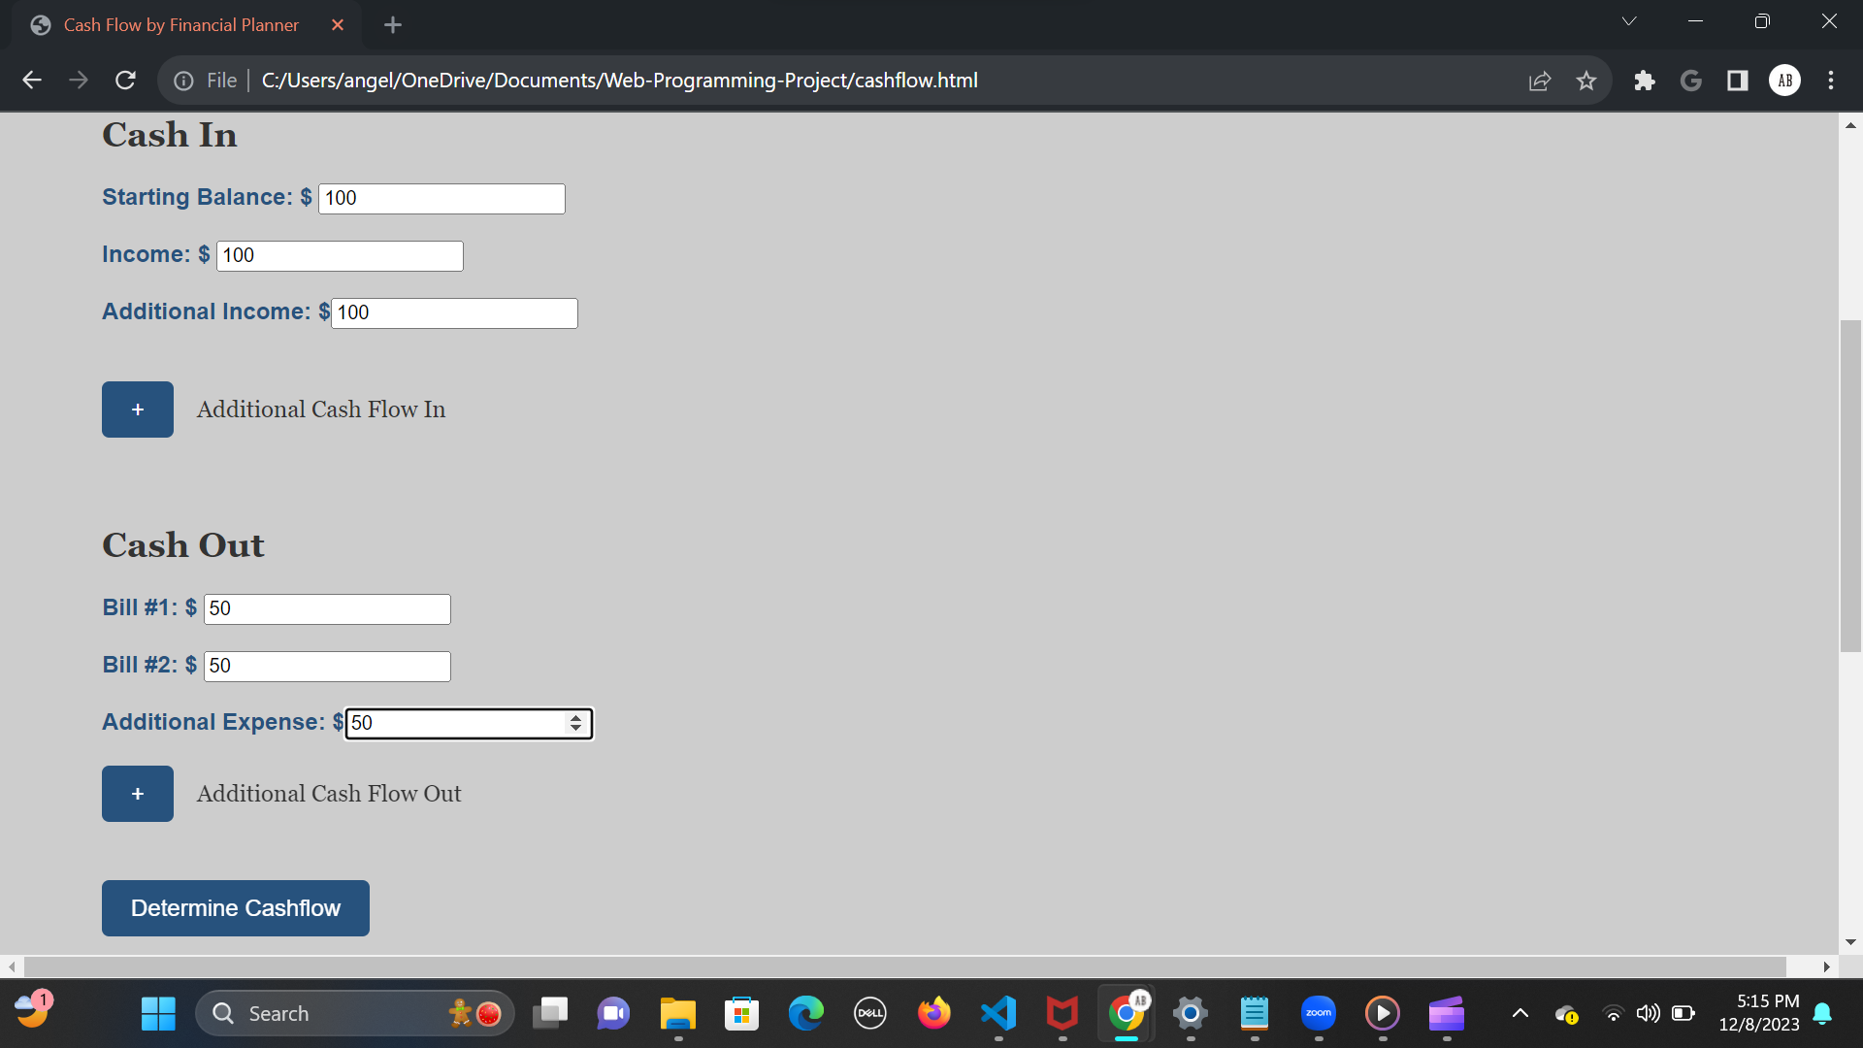

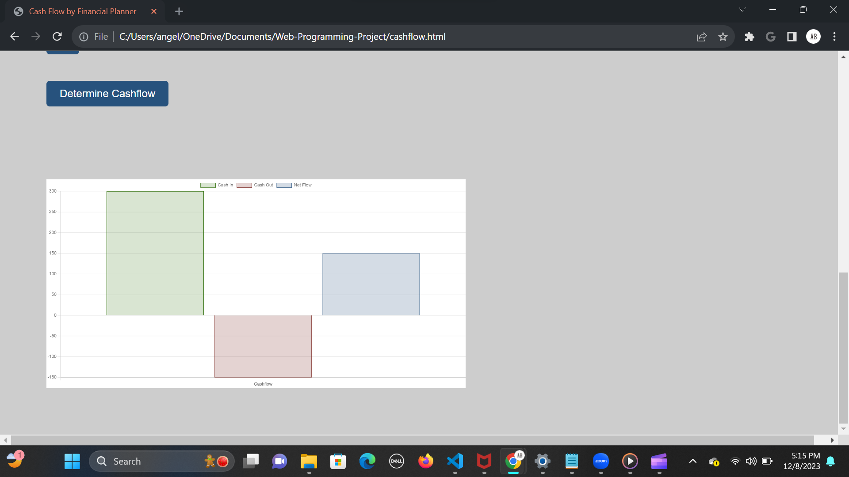

## Appendix B: Demo Video

We have our videos attached in the zip folder. There are three short videos in total.

## Appendix C: Source Code Repository

<https://github.com/abajr516/Web-Programming-Project>